**Breathing LED || Control Brightness of LED || Arduino Projects**

**What is a Breathing LED?**

* A **breathing LED** is an LED whose **brightness gradually increases and decreases**, creating a soft "breathing" effect.
* This effect is achieved using **Pulse Width Modulation (PWM)**.

**2. Components Required**

| **Component** | **Quantity** |
| --- | --- |
| Arduino Uno | 1 |
| USB Cable | 1 |
| LED | 1 |
| 220Ω Resistor | 1 |
| Breadboard | 1 |
| Jumper Wires | Few |
|  |  |

In this breathing LED project, several basic electronic components are used to bring the circuit to life. At the core of it is the Arduino Uno, a microcontroller board that acts as the brain of the project. It runs the program written in the Arduino IDE and sends out PWM (Pulse Width Modulation) signals to control the LED’s brightness. This gradual change in brightness is what creates the smooth "breathing" effect.

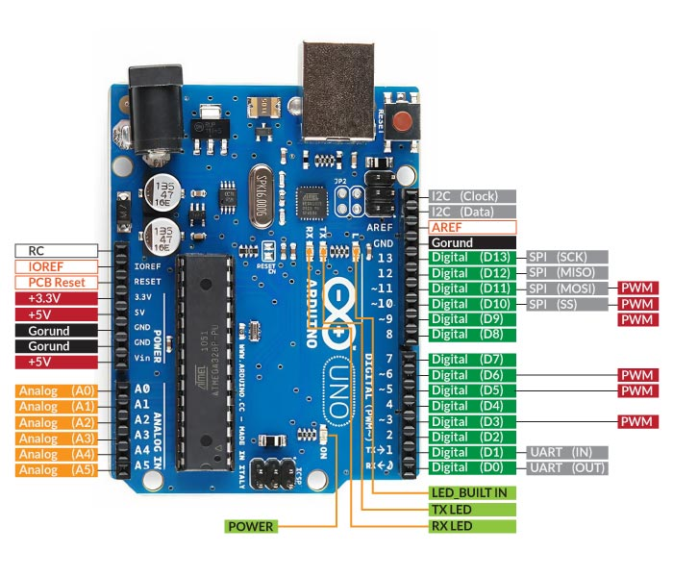

The LED, or Light Emitting Diode, is the main output device in this setup. It glows when current flows through it in the correct direction. LEDs are polarity-sensitive, meaning they must be connected the right way — the longer leg (anode) goes to the positive voltage, and the shorter leg (cathode) connects to ground. To protect the LED from receiving too much current, a 220-ohm resistor is placed in series with it. This resistor acts as a current limiter, ensuring the LED receives just the right amount of current to operate safely without burning out.



All these components are assembled on a breadboard, which is a reusable platform used to build and test electronic circuits without any soldering. It allows for easy insertion and removal of components and makes prototyping simple and neat. The connections between the Arduino, the LED, the resistor, and the breadboard are made using jumper wires. These flexible wires help link various parts of the circuit and allow signals and power to travel through the setup.

Each of these components plays a specific role, and together, they allow the circuit to smoothly control the brightness of the LED, mimicking a natural breathing rhythm.

**3. Circuit Diagram & Connections**

**Circuit Explanation:**

* **LED** connected to digital pin **11** of Arduino.
* **Resistor (220Ω)** is used in series with the LED to **limit current** and protect the LED.
* **Connections**:
  + **Anode (+) of LED** → Arduino **Pin 11**
  + **Cathode (-) of LED** → One end of **Resistor**
  + Other end of **Resistor** → **GND** of Arduino

**4. Output**

**Simulation Platform:**

* Project was simulated using **Tinkercad**.

**Observed Result:**

* The **LED gradually gets brighter and dimmer**, resembling a natural breathing rhythm.

**5. Key Learning Points**

* PWM can control **LED brightness**.
* analogWrite() is essential for **smooth transitions**.
* Simple components can create elegant lighting effects.